Guide to Accessing Useful Systems
Citrix
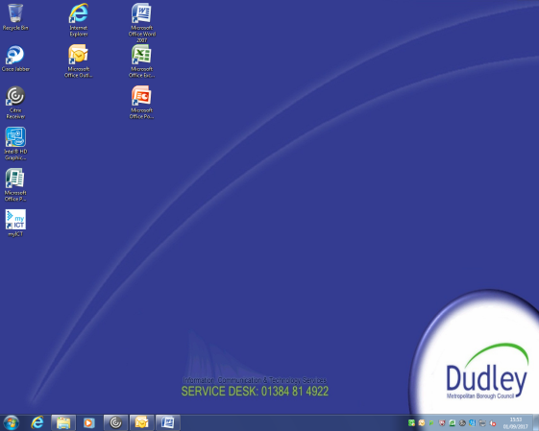
Citrix is a server that is used by Dudley Council and it can be found on your desk top

Employer Warning System
This is a tool to use to ensure your safety when making home visits etc.
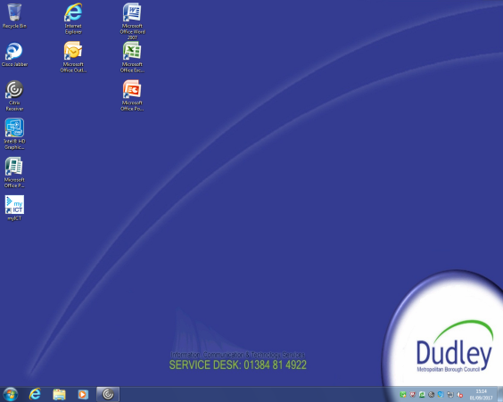
1/ On your desk top double click to open the Citrix icon.

2/ Click to on the Outlook icon to open it
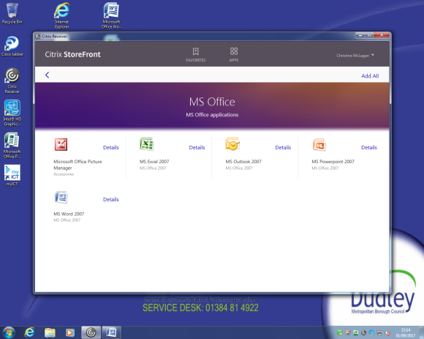

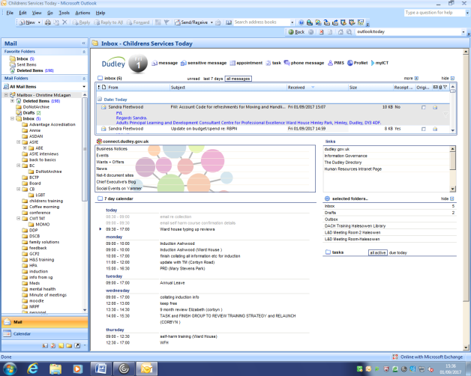
3/ Click onto the Mailbox then onto the Connect icon which is a 1/3 down on the screen

4/ Click onto Your Apps
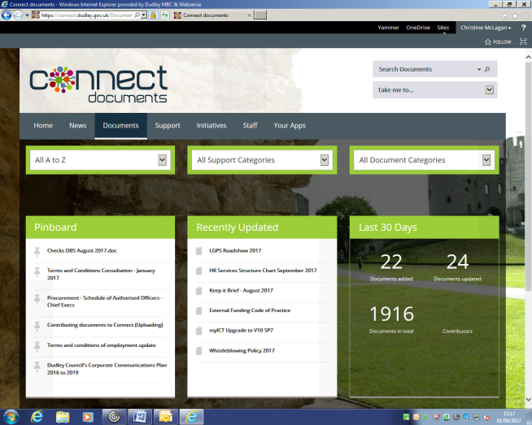

5/ Click on the EWS to access
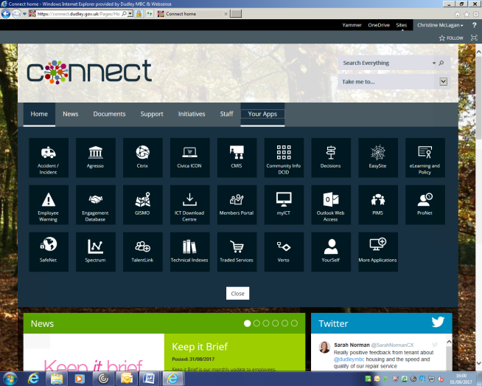
PIMS (Personnel Information Management System)
1/ On your desk top double click to open the Citrix icon.

2/ Click to on the Outlook icon to open it

3/ Click onto the Mailbox then onto the PIMS icon which is on the top right hand of the screen

PRONET
1/ On your desk top double click to open the Citrix icon.

2/ Click to on the Outlook icon to open it

3/ Click onto the Mailbox then onto the Pronet icon which is a 1/3 down on the screen

CCM – Children Case Management
This is a tool to use to ensure your safety when making home visits etc.
1/ On your desk top double click to open the Citrix icon.

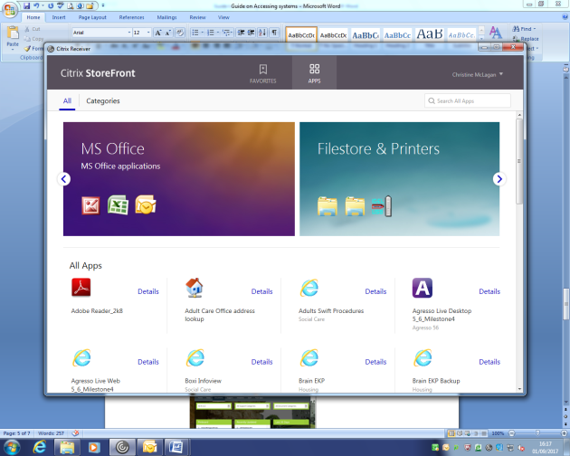
2/ Click to on the Outlook icon to open it then scroll down until you find the CCM icon

3/ CCM live icon CCM procedures icon click to open
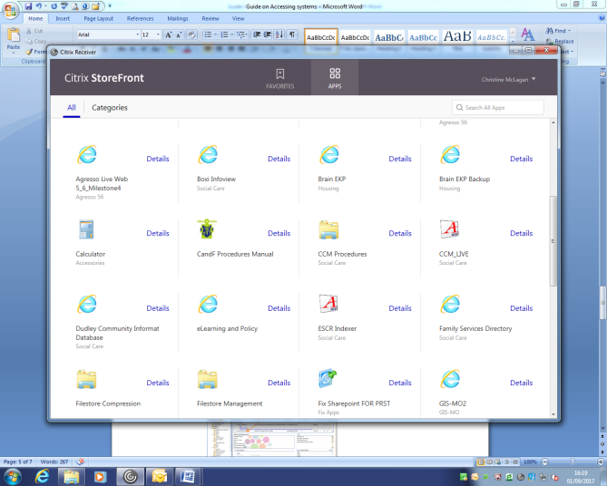

Policies and Procedures
1/ On your desk top double click to open the Citrix icon.

2/ Click to on the Outlook icon to open it

3/ Click onto the Mailbox then onto the Connect icon which is a 1/3 down on the screen

4/ Click onto Documents

5/ You can use the tabs to find the document that you are looking for or by A to Z
