|  |  |
| --- | --- |
| Name of Young Person/Adult |  |
| Liquidlogic Number |  |
| Date Completed | / / |
| Stage of Webstar | First ⬜ Midway ⬜ Closure ⬜ |

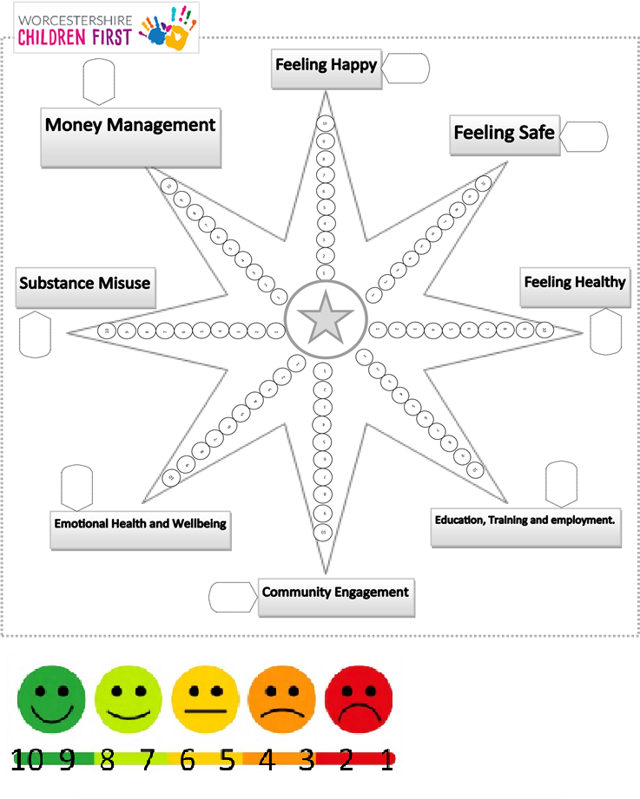

Previous Scores

|  |  |  |  |
| --- | --- | --- | --- |
| Happy |  | Community |  |
| Safe |  | EH&W |  |
| Healthy |  | Substance |  |
| EET |  | Finance |  |

1} Where would you rate yourself in terms of feeling happy?

Can you tell us what makes you happy?

2} Where would you rate yourself in terms of feeling safe and what makes you feel safe?

3} Where would you rate yourself in terms of feeling healthy & why?

4} Are you involved in Education, training or employment? How would you rate yourself regarding this?

5} How engaged in your community are you? For example, are you regularly attending any sports clubs, leisure clubs, volunteering?

6}Emotional Health and Well Being. Prompt questions could be: do you feel isolated, lonely, do you have a trusted person in your life to talk to?

7} Can you tell us if Substance Misuse is affecting you or your family.

Young person ⬜ Parent ⬜ Both Parents ⬜ Whole Family ⬜ Not Applicable ⬜

8} Do Finances impact on your life?

Overall Family Finances ⬜ My Own Finances ⬜

