Families Come First

Introduction:
Families Come First is part of the wider vison of Dudley Council to improve the outcomes of families through repairing and strengthening relationships within families and within their wider networks to ensure children, their parents and carers realise their full potential.
The Families Come First team is a Child in Need service offering multi-disciplinary support to children and families, working with children up to the age of 17 whilst also delivering individualised support to care givers.
The team will hold full social work allocation for all Child in Need plans referred to the service where possible.
The service offers a wide range of specialist supports under a one team approach. Our staff group consists of.
Team Managers - Advanced Social Work Practitioners - Social Workers - Intensive Family Support Workers - IDVA - Money Mentors - Substance Misuse Workers – Family Support Workers - Emotional health & Well-Being Practitioners - Youth Mentors - Business Support - Emotional Health & Well-Being Lead
Through our work with children and their families each family member will build on their existing strengths and develop practical skills to manage familial tensions within their households. The team will also work with families and professionals to build wider support networks around our families within their own townships.
Vision:
We will keep children and young people at the heart of all that we do. Underpinning our transfer process is a common-sense approach. Conversations should be held between Managers and Social Workers to ensure that children receive timely support from the most appropriate service area.
A transfer process cannot regulate for every unique situation therefore it is important that the actions of the holding and receiving team managers remove bureaucratic barriers to ensure children and families receive the right support at the right time.
We will ensure that children & their families are informed of any changes within their support journey and wherever possible best practice will be followed with regards to introductory visits taking place to allow families to better understand why changes might need to be made and to capture the views and feelings of our families.
Transfer Standards:
- Families Come First will provide support to children where a CYPA assessment has been completed.
- Children/Parents & Carers should be fully informed of any transition between teams/services.
- Introductory joint visits will take place where possible between the holding Social Worker and in-coming team.
- Team Managers must ensure effective and timely conversations are held between in coming and holding Social Workers to support clear information sharing regarding the plan for the child/family and any identified risks.
- Management Oversight should always be evident on LCS regarding a transfer between teams/services.
- Team Managers & Practitioners should look to remove any barriers to a timely transfer.
- The transfer summary checklist will ensure that all relevant documentation is completed for points of transfer.
- Where possible all LCS tasks work should be updated by the holding Social Worker at point of transfer. If incomplete tasks remain this will require an LCS note to reflect a conversation between Team Managers with a plan regarding timescales for the completion of any work. (chronology/genogram/case summary).
- Receiving Team Managers require as early notification of transfers as possible to support and enable teams to work together, to ensure smooth transitions and to provide in-coming teams time to allocate a worker to attend the Child in Need Meeting, Initial Child Protection Conference, Looked After Review/Placement Meetings.
- Transfer Point Meetings are to be attended by the out-going & in-coming Social Worker. If this is not possible a representative from the respective teams will attend.
These overarching practice standard in Dudley Council should always be a One Service Approach.

Requesting Edge of Care Support from Families Come First.
Any team considering a referral to Families Come First Edge of Care support should be clear about why this family are deemed to be on the Edge of Care within the referral form. The referral needs parental consent which will require the allocated social worker to fully inform parents of the support that is provided by the Families Come First Team.
Information leaflets and links are available from Families Come First team to support Social Workers to hold these conversations with families.
Creating an Edge of Care Referral in LCS.
- Go to the forms page on the young person’s record
- Start New Form
- Edge of Care – Referral
- Copy forward selected information and complete the one page referral.
- Send for Authorisation as per below.
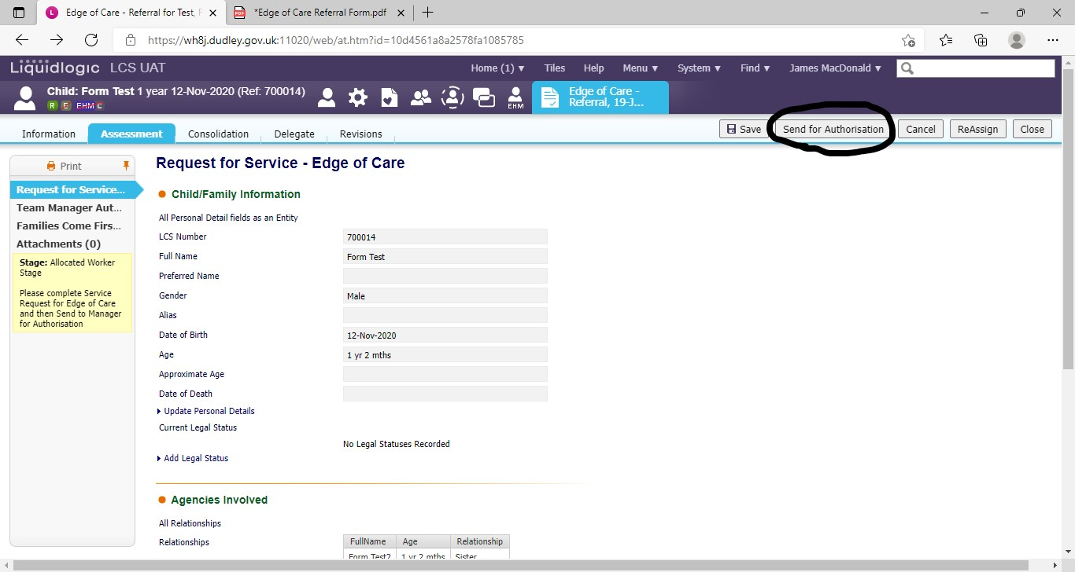

The referral is sent to the team tray of Families Come First (FCF) and will ordinarily be responded to within 24 hours.

Where there is a need for urgent Edge of Care support because of escalating risk it is important for the currently allocated social worker to make immediate phone contact with the Families Come First Management team to make this request, followed by a completed referral form.
Team Manager: Heather Dudfield
Duty Number: 01384 815676

Before allocation to Families Come First (FCF) a discussion will take place between the Advanced Social Work Practitioner (ASWP) and the current allocated Social Worker to develop further information and inform swift decision making. Where required a discussion with the family will be undertaken by the ASWP.
Families Come First aims to hold all of these initial discussions within the 24hr window.
Families Come First is not a crisis team but can provide a quick response to requests for intensive support for Child in Need families.
Once allocated to FCF a joint introductory visit should take place during the co-working stage. When completed and the family are fully informed about the changes in professionals, an appropriate point of transfer should be identified, ordinarily this will be the Child In Need meeting.

Requesting Child in Need support. (Not Edge of Care)
Families Come First will now work with our colleagues in the Assessment team to transfer Child in Need Families.
- The Assessment Team will have completed a CYPA assessment that details the need for a Child in Need plan.
- An LCS transfer summary and checklist will be completed by Assessment Social Worker & Team Manager and sent to Families Come First.
- Families should always be fully informed about the support offered from the Families Come First team and consent should be evident on file.
- Parental leaflets and videos are available from the team to support all staff in holding these conversations with children and their families.
- Child in Need meetings, times & dates should be arranged with families but will also require a discussion between in-coming and out-going social work to ensure all are in attendance.
- Wherever possible an introductory visit, phone call or virtual meeting should take place prior to the Child In Need meeting.

The flow of Child in Need families from Assessment teams into Families Come First should have a business-as-usual feel and the transfer point will always be the Child In Need meeting which the assessment worker will arrange and chair.
Families Come First will record the first Child in Need meeting.
Transfer Standards listed will apply in how Families Come First receive allocations from our colleagues in Assessment Teams but will not act as a barrier to not working with a child until a process has been completed.

Child in Need Criteria
Children in Need covers such a broad spectrum of needs for children and young people and we recognise that not all children in need will benefit from this multi-disciplinary approach. Therefore, for the purposes of referral criteria for Families Come First we will identify Child in Need who will move to Families Come First and those that will continue to transfer to Safeguarding & Support.
We must consider that when we start to define Children in Need by categories, we can lose sight of the individual and what is right for the child & family at that time.
We must always think flexibly and understand that referral criteria cannot account for every unique set of circumstances within families. We should always place children and families at the heart of our decision making.
The team will work with our colleagues in Assessment to identify appropriate transitions for Children in Need into Families Come First.
Those children that are not within scope for Families Come First support are.

- CIN Children with disabilities that meet the criteria for CWD.
- CIN in Care Proceedings or Private Law Proceedings e.g. Section 7 / 37 cases.

- CIN step down from Child Protection plans
- CIN on supervision orders
- CIN children who are unborn and need Parenting Assessments.
- CIN Private Fostering
- CIN 16-17-year-olds who are at risk of or are homeless and require a Southwark Assessment. FCF will support colleagues in Assessment where required to inform decision making for this cohort of young people.
- CIN where Pre-Birth Planning is sole consideration.
- CIN delegated LA cases
- CIN relinquished babies
- CIN transfer in cases from other LA’s where a SWA is required to determine case transfer. CP/LAC.
- CIN no recourse to public funds
- CIN where Placement with Parents’ Regulations are ending.
- CIN where Gateway meetings have agreed LPM/LAC.
- CIN rereferred within 3 months of being closed to Safeguarding & Support. The previously allocated team will review the reason for the referral and the need for the case to be reopened or not.

Any consideration for a Child in Need Family being transferred into Families Come First should prioritise the need for multi-disciplinary support over formal Social Work assessments and process.
Families Come First retain a specialist Edge of Care remit in working with families under a Child in Need plan but will also work, where safe and appropriate to do so prevent Children in Need escalating to Child Protection.

Extension of Families Come First support.
Families Come First will work with families for a maximum of 18 weeks unless there are exceptional circumstances.
Any decision to extend support beyond this will be informed by the FCF practitioners involved with the family and the Team Manager after 14-16-weeks to inform direction.
Management Oversight will be recorded on LCS and will include detail of a discussion and agreement with the Service Manager

Child Protection:
The transfer point out of Families Come First for Child Protection is the Initial Child Protection Conference.
Families Come First will notify Safeguarding & Support on day 5 after the Strategy Discussion of the intention to call an ICPC. The Safeguarding & Support Manager will advise of who the receiving Social Worker will be within 5 days and Supporting Families Social Workers from both teams will begin information sharing prior to the conference.

Families Come First will remain involved with the family on a co-working basis until any planned work is completed on the originally agreed timescales with the family.

Becoming Looked After:
Where the Families Come First Team have received agreement for a young person to become looked after and the plan is not to re-unify or the young person is over the age of 16 and determining their own Section 20 status under the Southwark Judgement a transfer will take place to the Children in Care Team.
The transfer point out of Families Come First for any child who becomes Looked After is the 1st Looked After Review.
This transfer will take place to the Children in Care team.
Families Come First can remain involved with the family on a co-working basis until any planned work is completed, particularly if Emotional Health & Well-Being Support is currently in place. This will be agreed by Team Managers and recorded on LCS with clear timescales.
If it is possible for the Social Worker in Families Come First to build a re-unification plan back home for the child during the weeks before the 1st Looked After meeting the FCF team will plan to do this and maintain holding of the child/family to reduce the transition journey of the child. Re-unification planning must be assessed and evidence as a possibility within the 4 weeks leading to the 1st Looked After Review and have clear Team & Service Manager direction on LCS.
Where there are siblings within the family that are not accommodated and remain on a Child in Need plan the work of the team remains relevant Families Come First will complete their work and remain the allocated team. It is important to maintain open dialogue between involved social worker, the child and the family.
Any young person who is accommodated under Section 20 will have clear reason for this recorded on Liquid Logic by the Families Come First Service Manager which will detail legal dialogue and why legal applications are or are not being sought at that time.
Leading up to the Looked After review it is important that children and parents are fully informed about changes in social workers/teams.

It is equally as important that wherever possible joint introductory visits have been undertaken between the incoming and allocated social workers. Children should not meet their new social worker in a formal meeting.
Families Come First will complete the assessment for the Review and will end their involvement after the review. All introductory visits should have taken place in those 4 weeks leading up to review, parents should have met the new social worker prior to the review and all professionals should be fully informed.

Legal Advice & Legal Gateway
Where a child is accommodated under Section 20, the decision and plan needs to be reviewed at Legal Gateway Panel within ten working days.
Families Come First will notify the Children in Care team and the transfer meeting remains the 1st Looked After Review.
Discussion and planning will take place within Gateway in relation to legal processes and any joint work that will be required.
The receiving Social Work team, ordinarily Children in Care will attend any legal planning discussions.

Emergency Protection Order
In the event that a child or young person is made subject to an Emergency Protection Order, the allocated team will remain responsible until one of the subsequent transfer points apply, which will most likely be under the guise of an Interim Care Order.

Stepping Down support from Families Come First
The Social Worker & the family will discuss and agree what type of stepped down support is required for the family when FCF reach the stage of ending the Child in Need plan.
Any need for on-going support will take consideration of level 3 support and community based voluntary support. The team should consider this through the course of of our intervention but most importantly should start to build this into the plan after 12 weeks.

The team will follow the existing protocol for Stepping Down into Early Help (below) and will notify the receiving Manager at the earliest stage to ensure at week 18 the transfer can take place.

Dudley Council Step Down Process
Where a service deems it necessary that a child or young person can step down to Early Help, the transfer will take place following agreement obtained from the Transfer Panel. In order for this to take place, the requesting service must complete the following.
- Present at Transfer Panel
- If agreed transfer, contact the relevant family centre for case discussion
- Ensure that at the transfer point, the Audit Checklist is completed

We will always ensure the family are at the heart of our decision making and fully informed about any changes in support.
- Exit from a family can create additional anxiety for families after receiving intensive levels of support, therefore the FCF team will always graduate closure with families , always looking for points in the 18 week timeframe where the family hold more autonomy themselves to build their confidence.
- A final Plan on a Page/Child In need plan will detail who can provide support if the family’s needs change in the future or where there is a need for on-going Level 3/ community-based support.
- Any external professional involved in the exit plan should have been consulted about their level of input and should have a copy of the plan with consented from the family.
- Introduction to any new professional and resource should form part of the graduated Families Come First plan.

Families Come First

